# CMPE-275 LAB2 GROUP 5

**Group Member Information:**

* **Name:** Saicharan Peda **SID:** 016019055
* **Name:** Raviteja Gannarapu **SID:** 016650972
* **Name:** Sarat Kumar Kaniti **SID:** 015906176
* **Name:** Ramya Kotha **SID:** 016023436

**Cloud Service:** AWS (EC2, RDS)

**Hostname:** [http://ec2-54-176-215-101.us-west-1.compute.amazonaws.com:8080](https://ec2-54-176-215-101.us-west-1.compute.amazonaws.com:8080)

CMPE-275 LAB2 GROUP 5

1. Get a passenger

2. Create a passenger

3. Update a passenger

4. Delete a passenger

5. Get a reservation

6. Make a reservation:

7. Update a reservation

8. Cancel a reservation

9. Get a flight

10. Create or update a Flight

11. Delete a flight

**Request Response Screenshots:**

### **Get a passenger**

* 1. **JSON URL:** <http://ec2-54-176-215-101.us-west-1.compute.amazonaws.com:8080/passenger/5ef75047-e038-4c4f-9d67-b3b324bc71f7?xml=false>

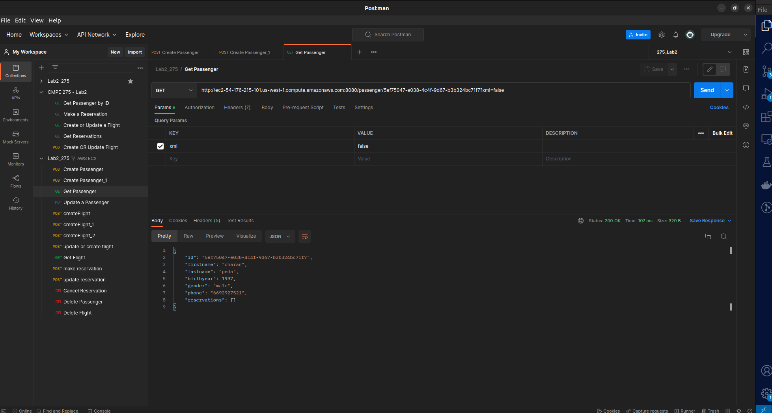

* 1. **XML URL:**

<http://ec2-54-176-215-101.us-west-1.compute.amazonaws.com:8080/passenger/5ef75047-e038-4c4f-9d67-b3b324bc71f7?xml=true>

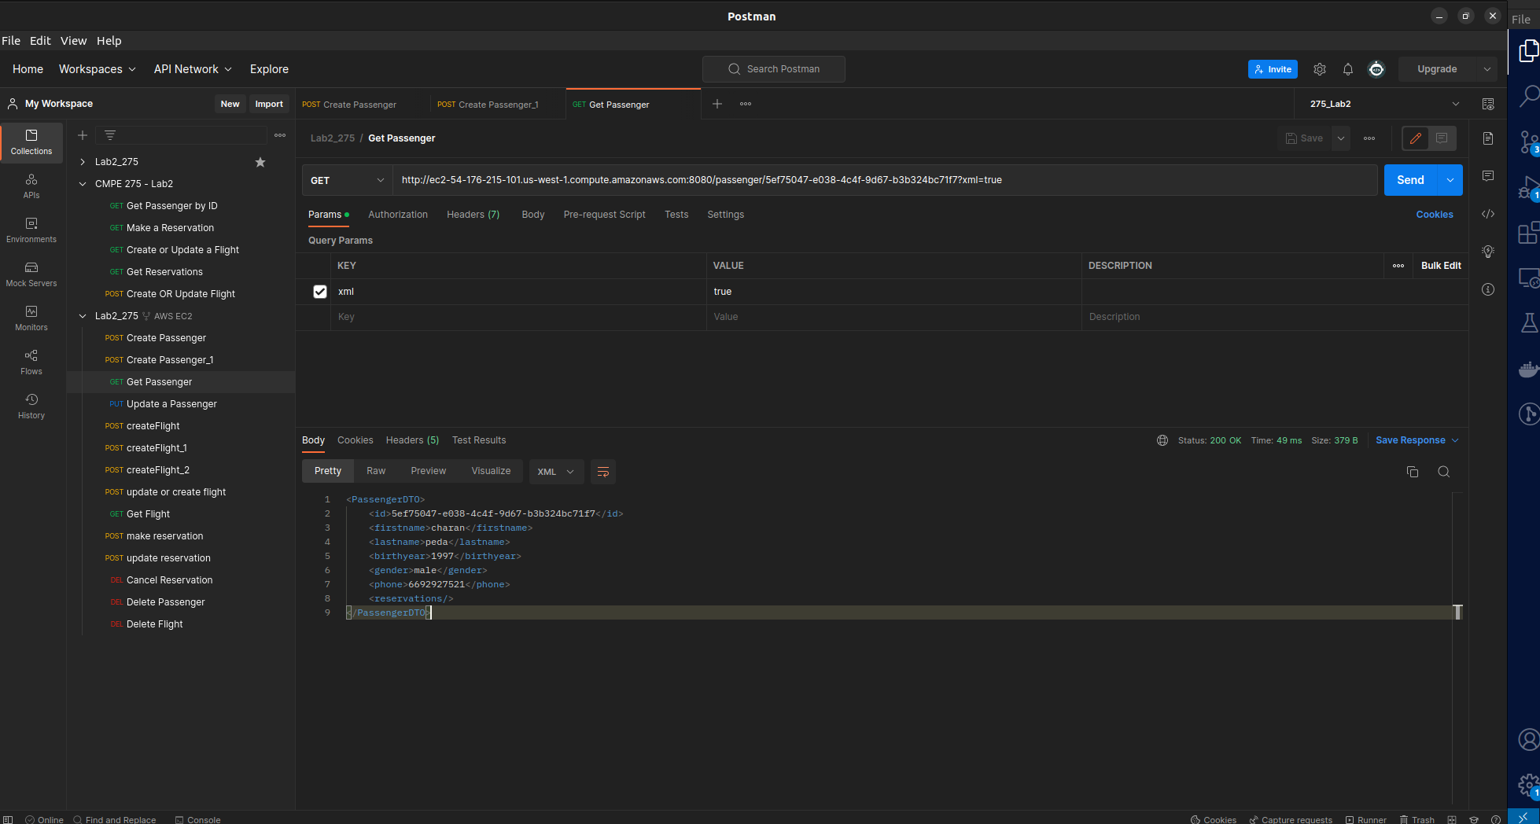

### **Create a passenger**

* 1. **JSON URL:** <http://ec2-54-176-215-101.us-west-1.compute.amazonaws.com:8080/passenger?firstname=charan&lastname=peda&birthyear=1997&gender=male&phone=6692927521&xml=false>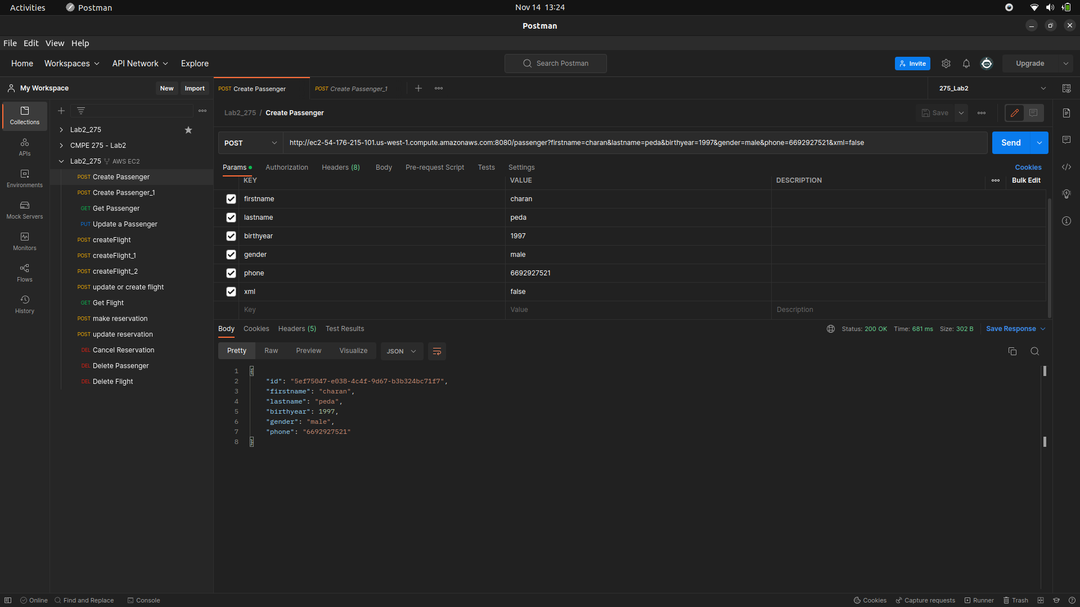
  2. **XML URL:**

<http://ec2-54-176-215-101.us-west-1.compute.amazonaws.com:8080/passenger?firstname=charan&lastname=peda&birthyear=1997&gender=male&phone=6692927521&xml=false>

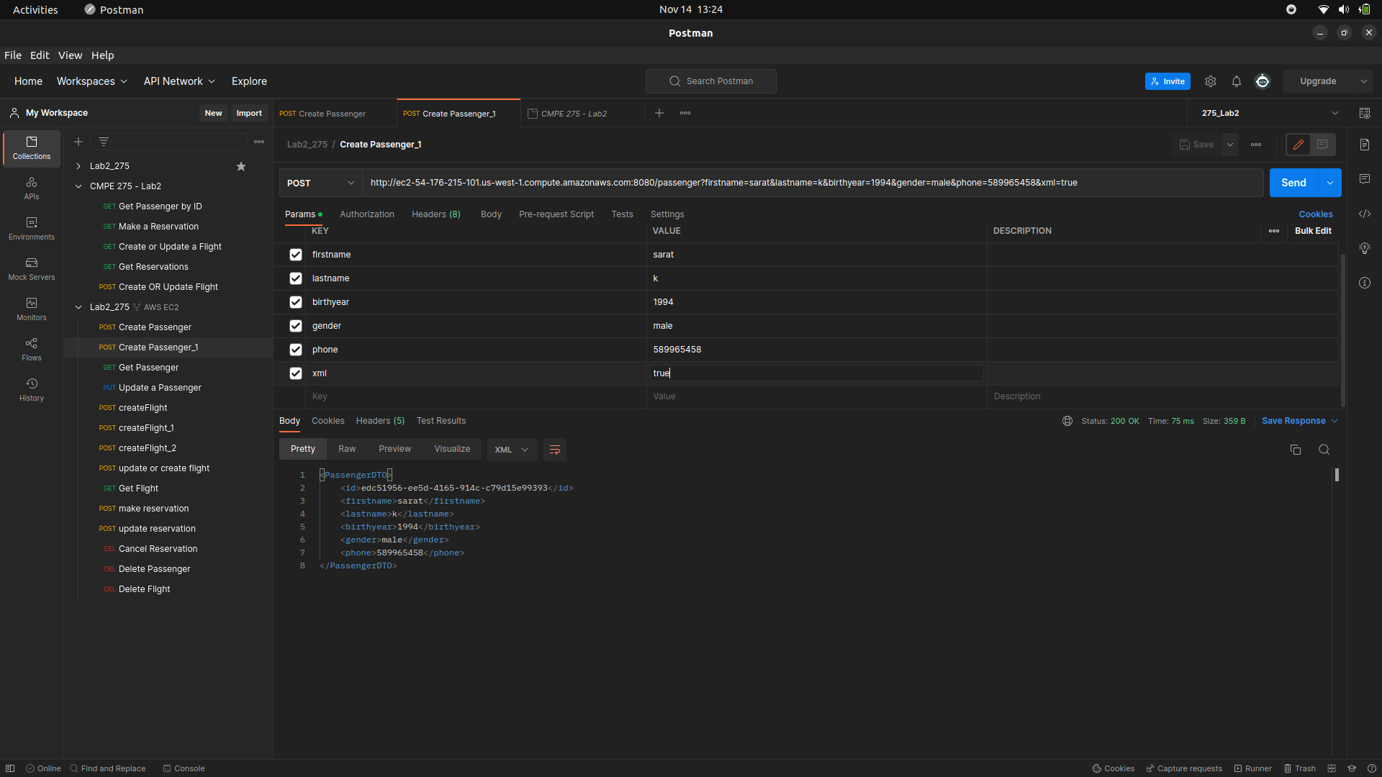

### **Update a passenger**

* 1. **JSON URL:** <http://ec2-54-176-215-101.us-west-1.compute.amazonaws.com:8080/passenger/5ef75047-e038-4c4f-9d67-b3b324bc71f7?firstname=saicharan&lastname=peda&birthyear=1997&gender=Male&phone=6692927522&xml=false>

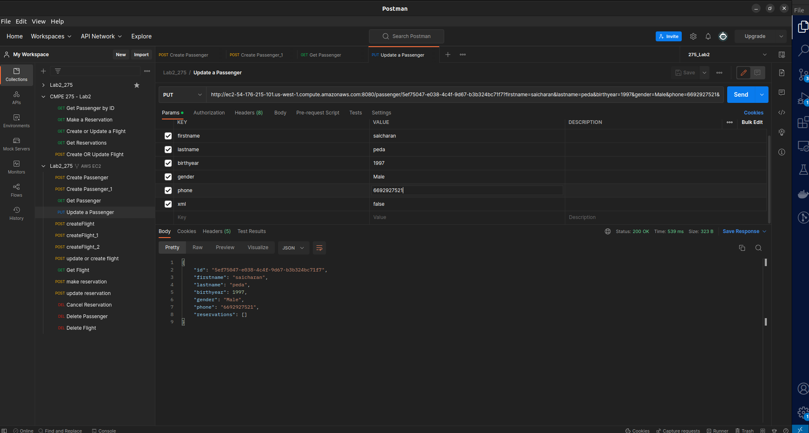

* 1. **XML URL:**

<http://ec2-54-176-215-101.us-west-1.compute.amazonaws.com:8080/passenger/5ef75047-e038-4c4f-9d67-b3b324bc71f7?firstname=saicharan&lastname=peda&birthyear=1997&gender=Male&phone=6692927522&xml=true>

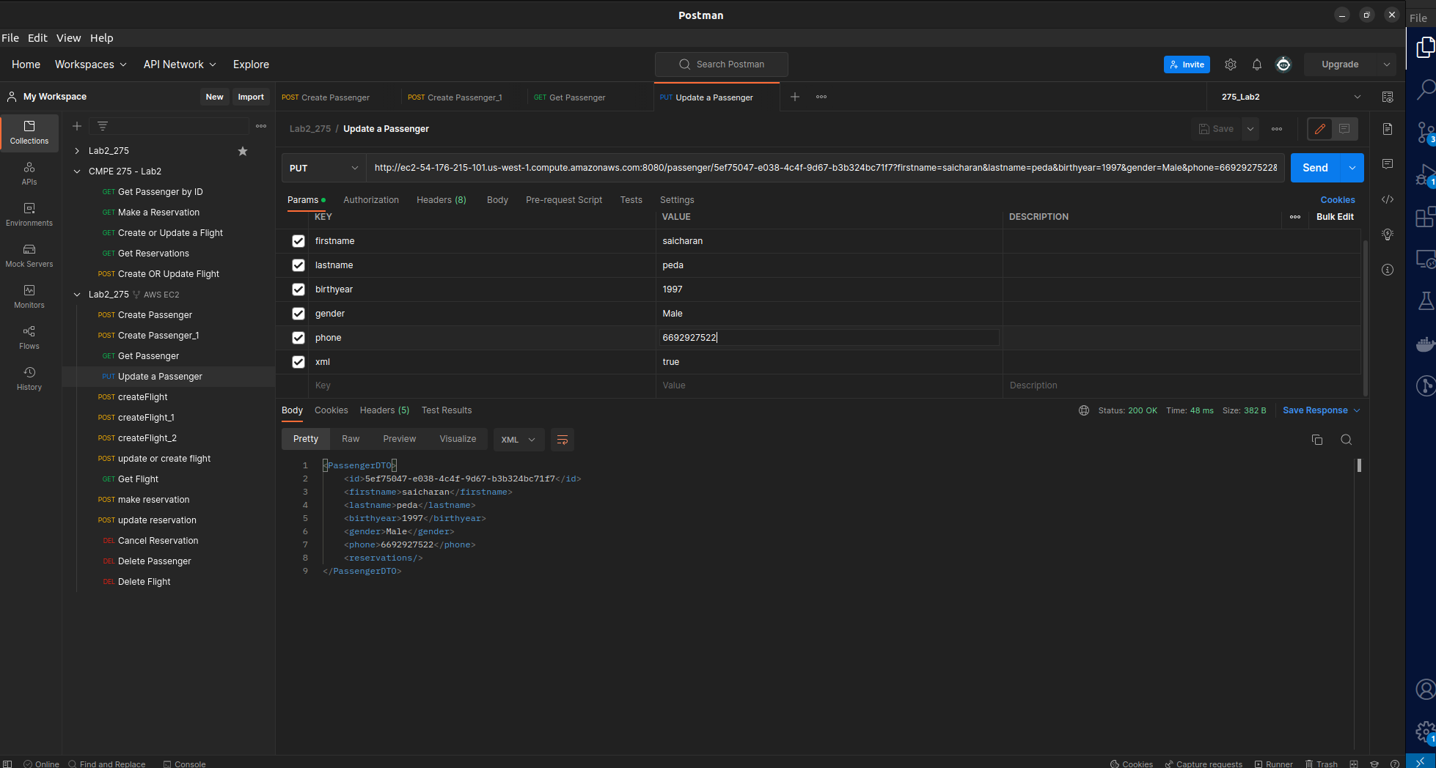

### **Delete a passenger**

* 1. **JSON URL:** <http://ec2-54-176-215-101.us-west-1.compute.amazonaws.com:8080/passenger/97b15614-03f4-43ca-a0de-090789f2d800?xml=false>

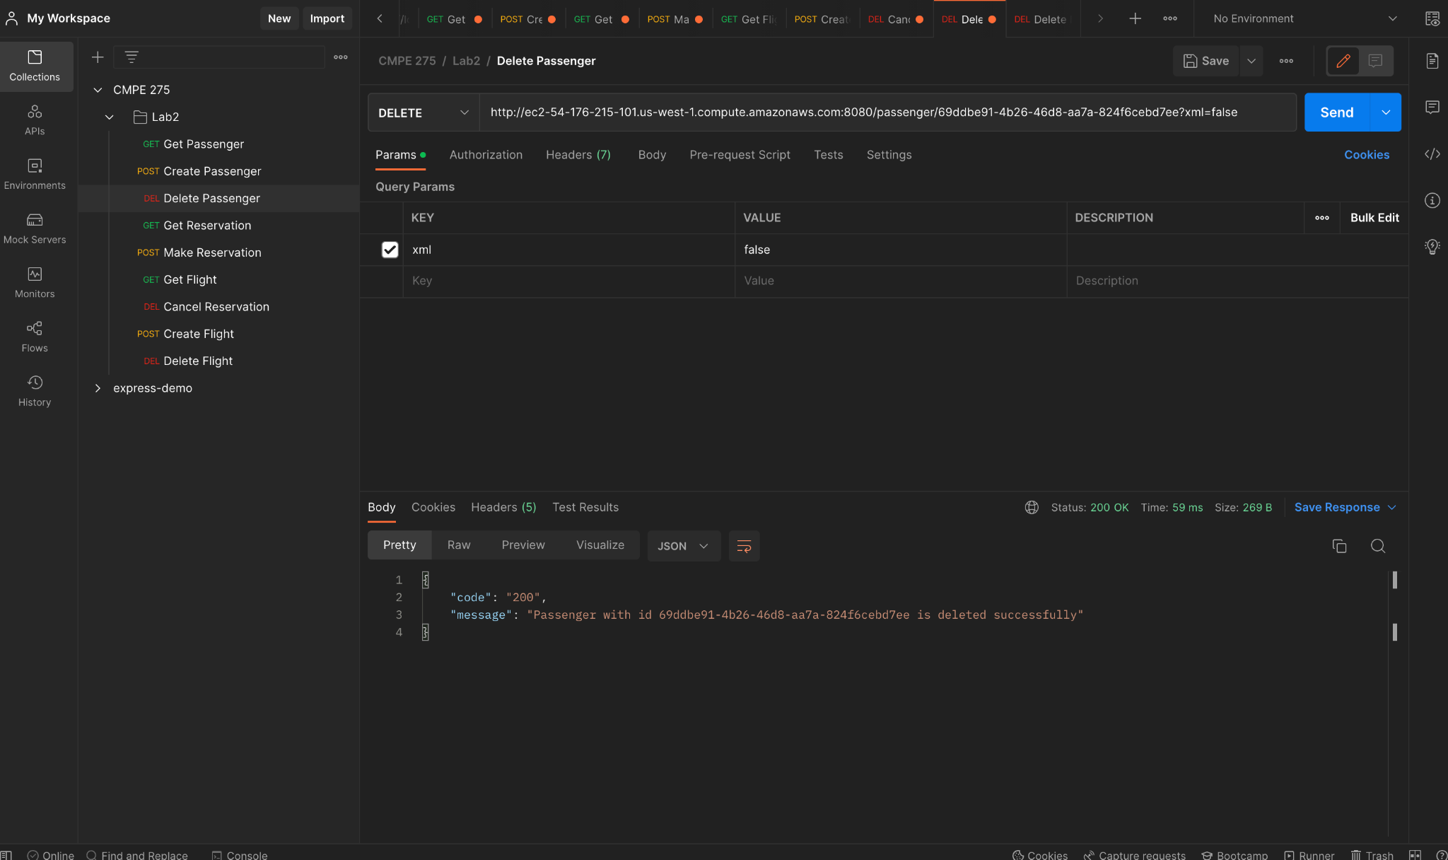

* 1. **XML URL:**

<http://ec2-54-176-215-101.us-west-1.compute.amazonaws.com:8080/passenger/d6a536fe-b66d-42e7-9d93-8cae63e7f446?xml=true>

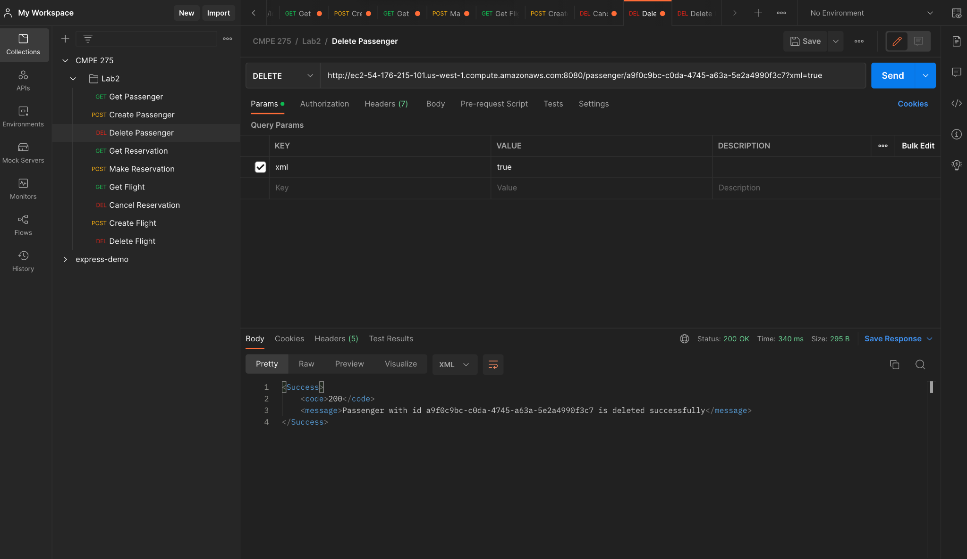

### **Get a reservation**

* 1. **JSON URL:** <http://ec2-54-176-215-101.us-west-1.compute.amazonaws.com:8080/reservation/1c8c79d1-aeab-488e-8824-654c10f3c7a3?xml=false>

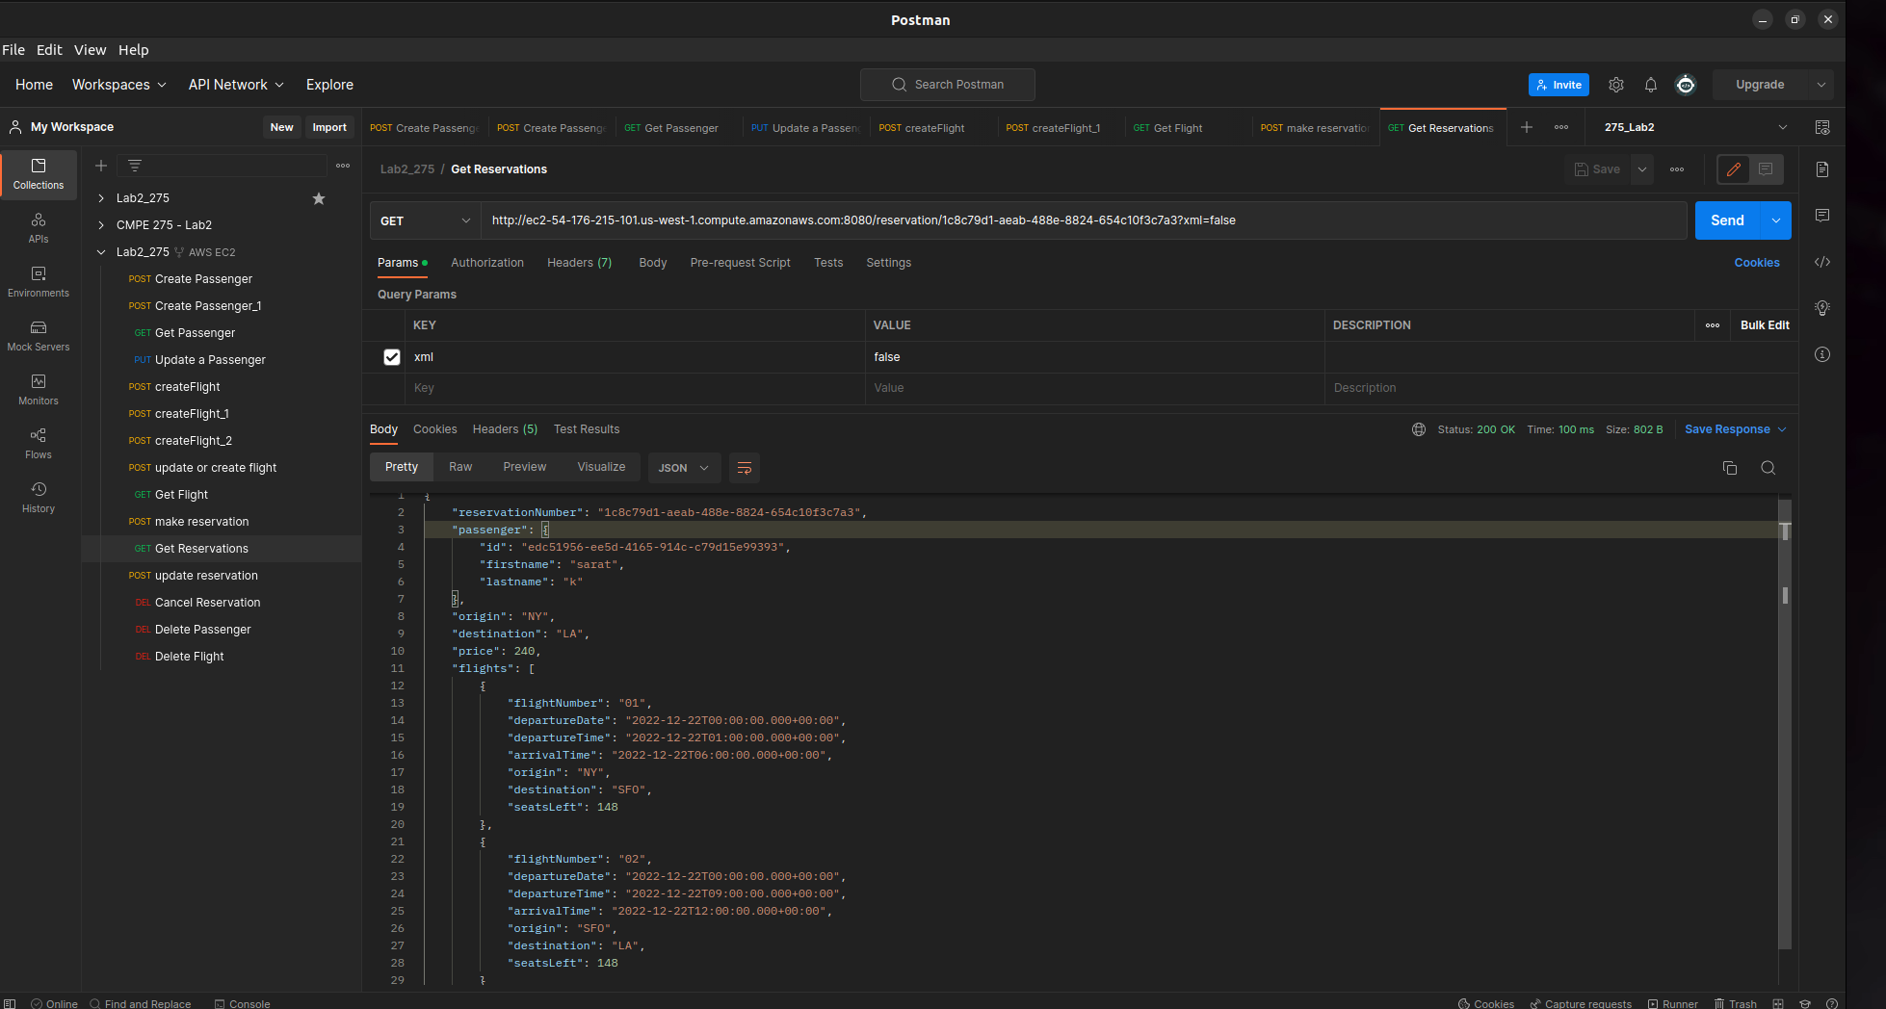

* 1. **XML URL:**

<http://ec2-54-176-215-101.us-west-1.compute.amazonaws.com:8080/reservation/1c8c79d1-aeab-488e-8824-654c10f3c7a3?xml=true>

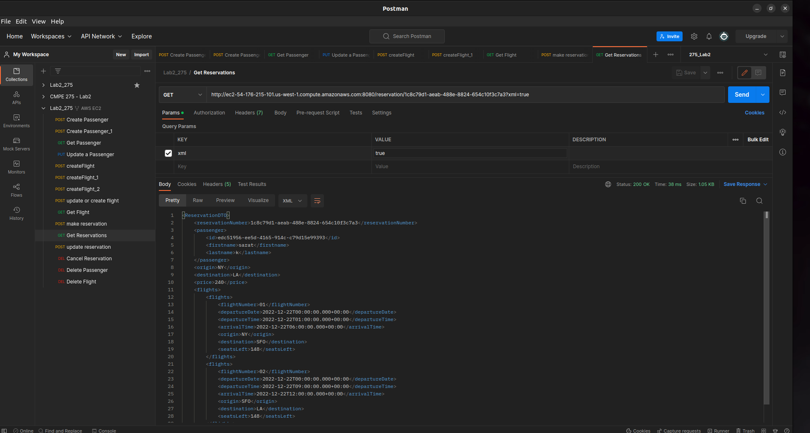

### **Make a reservation:**

* 1. **JSON URL:** <http://ec2-54-176-215-101.us-west-1.compute.amazonaws.com:8080/reservation?passengerId=5ef75047-e038-4c4f-9d67-b3b324bc71f7&departureDates=2022-12-22,2022-12-22&xml=false&flightNumbers=01,02>

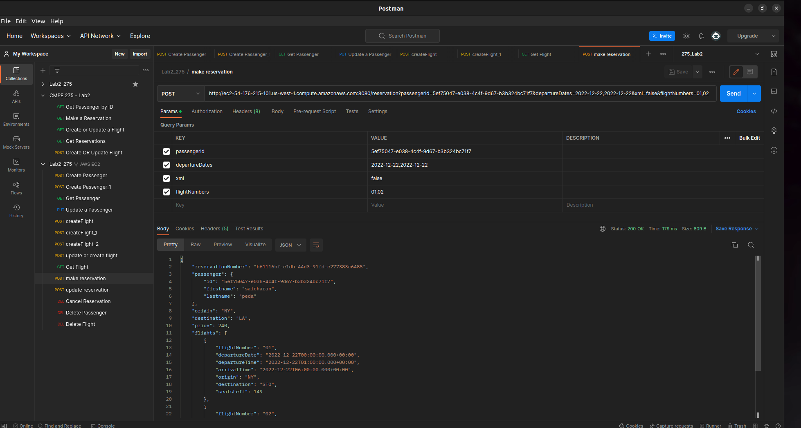

* 1. **XML URL:**

<http://ec2-54-176-215-101.us-west-1.compute.amazonaws.com:8080/reservation?passengerId=edc51956-ee5d-4165-914c-c79d15e99393&departureDates=2022-12-22,2022-12-22&xml=false&flightNumbers=01,02>

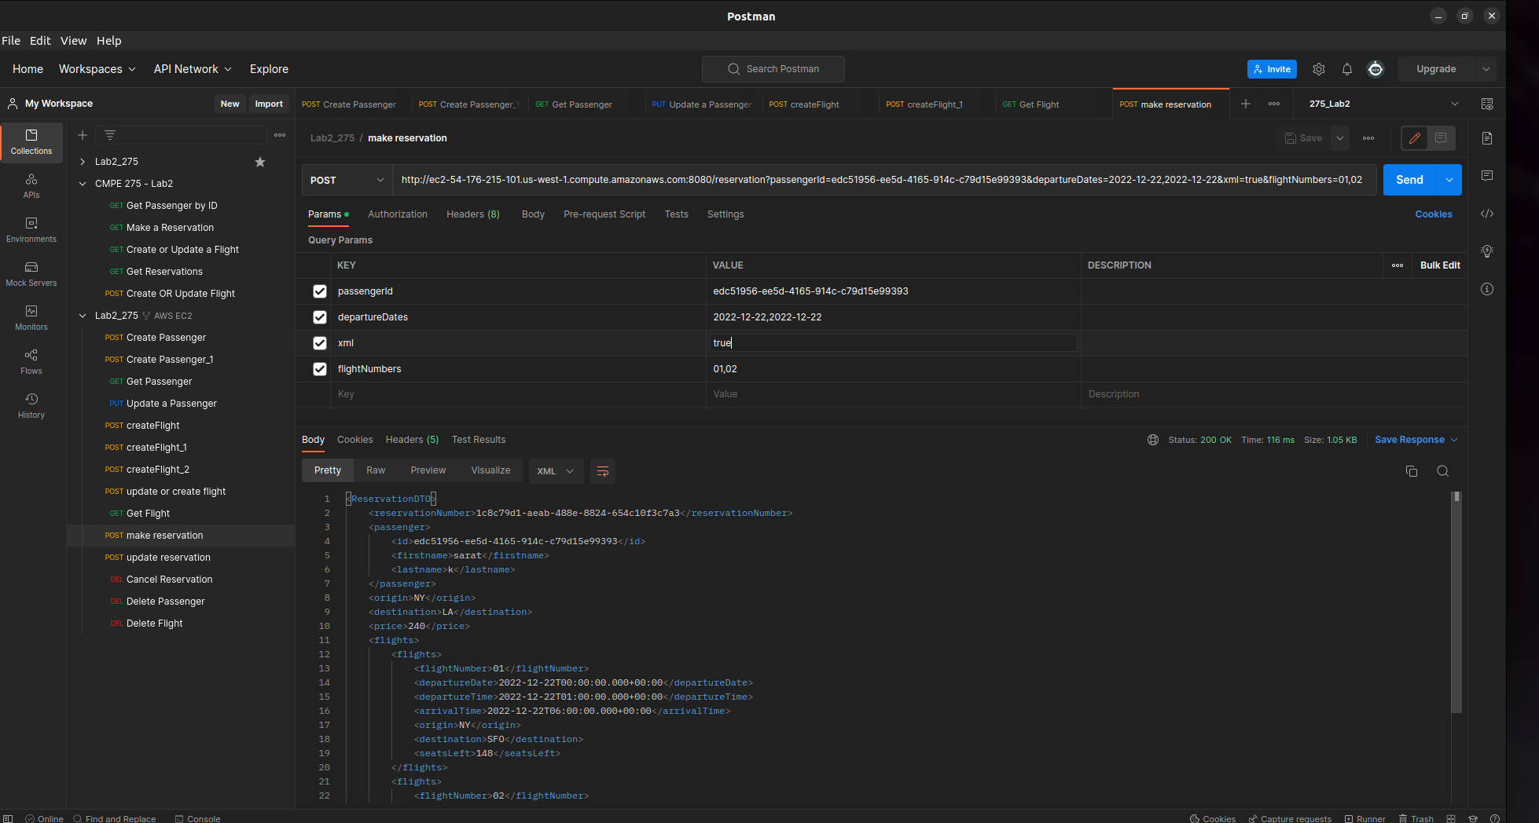

### **Update a reservation**

* 1. **JSON URL:** <http://ec2-54-176-215-101.us-west-1.compute.amazonaws.com:8080/reservation/f75d9dd2-df37-4513-b62f-c42fafc02e78?flightsAdded=02&departureDatesAdded=2022-12-22&xml=false>

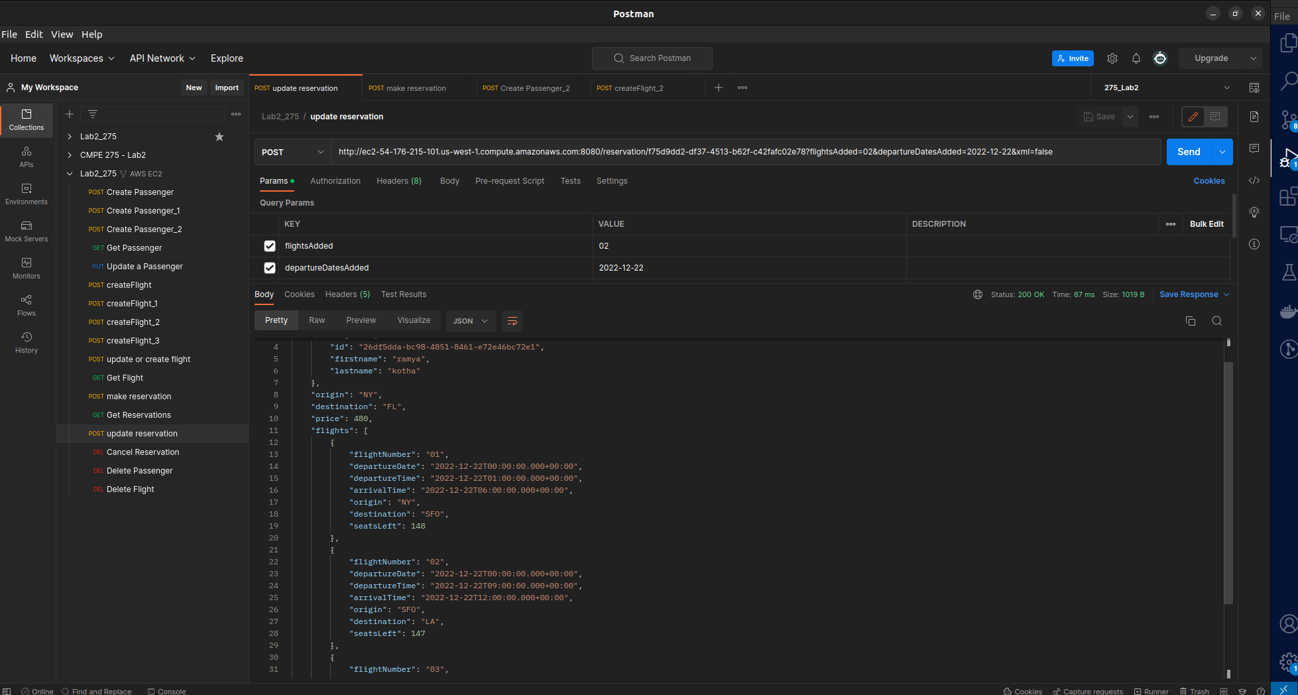

* 1. **XML URL:**

<http://ec2-54-176-215-101.us-west-1.compute.amazonaws.com:8080/reservation/f75d9dd2-df37-4513-b62f-c42fafc02e78?flightsRemoved=02&departureDatesRemoved=2022-12-22&xml=true>

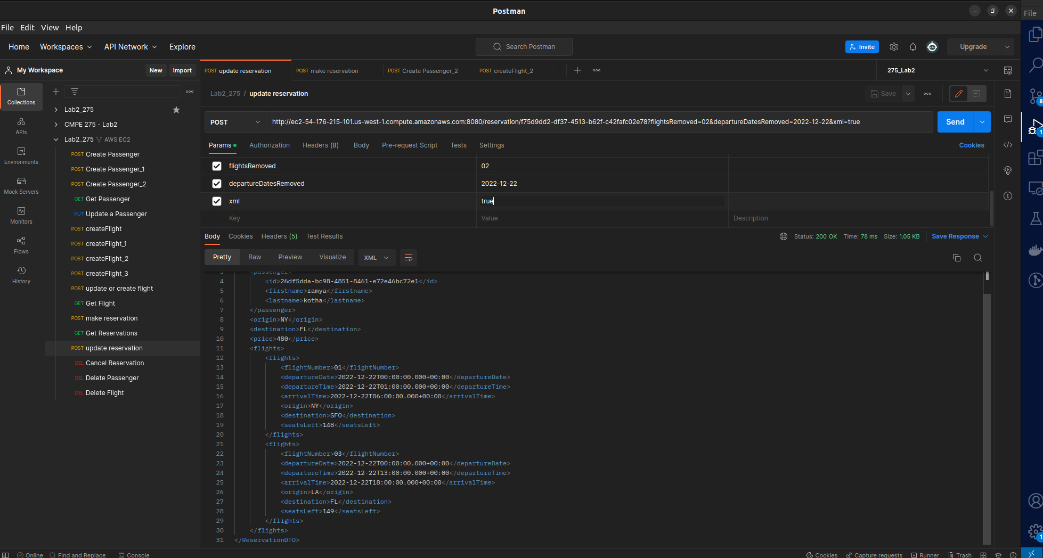

### **Cancel a reservation**

* 1. **JSON URL:** <http://ec2-54-176-215-101.us-west-1.compute.amazonaws.com:8080/passenger/5ef75047-e038-4c4f-9d67-b3b324bc71f7?xml=false>

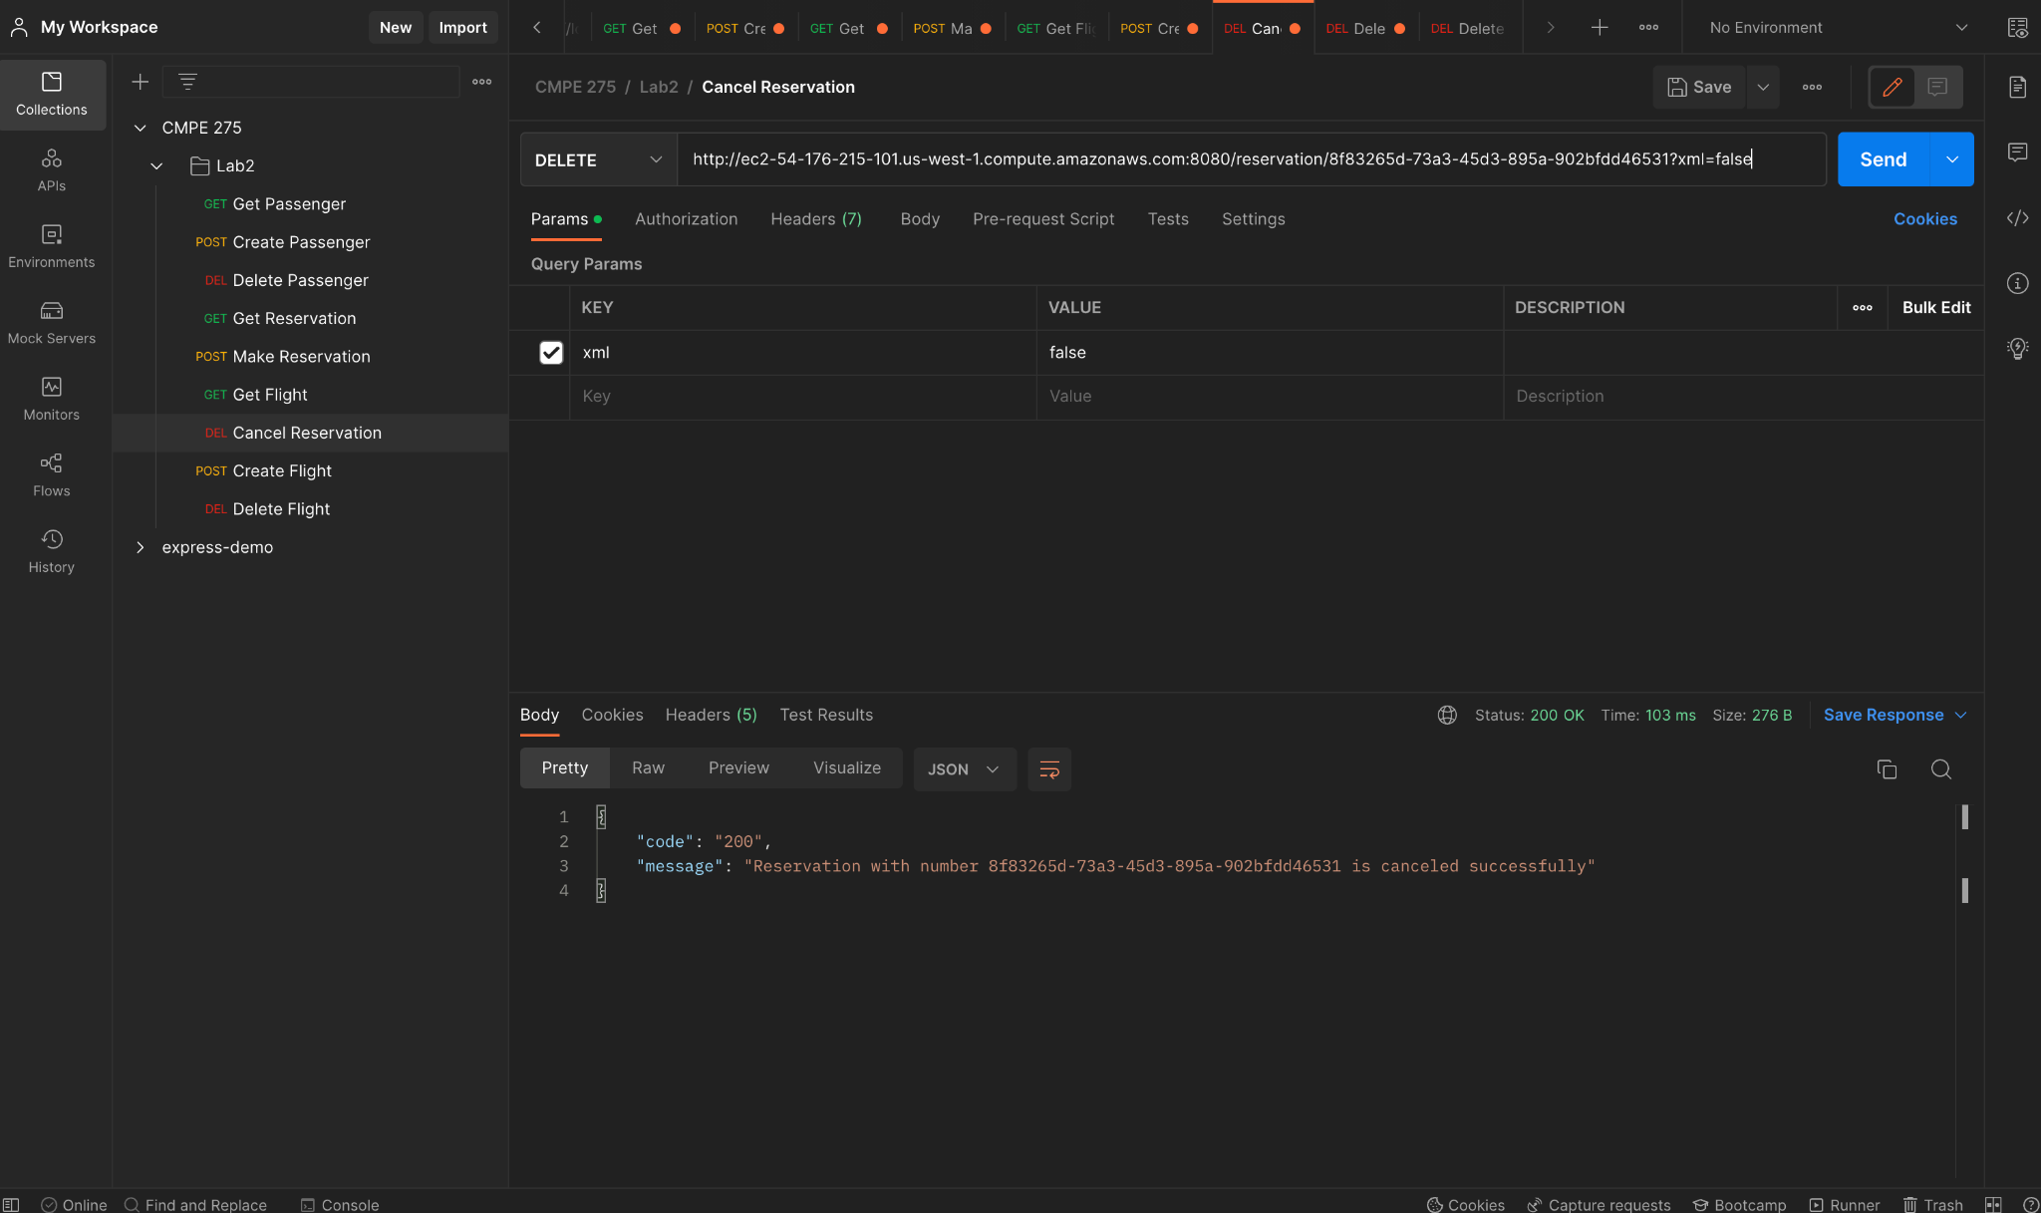

* 1. **XML URL:**

<http://ec2-54-176-215-101.us-west-1.compute.amazonaws.com:8080/passenger/5ef75047-e038-4c4f-9d67-b3b324bc71f7?xml=true>

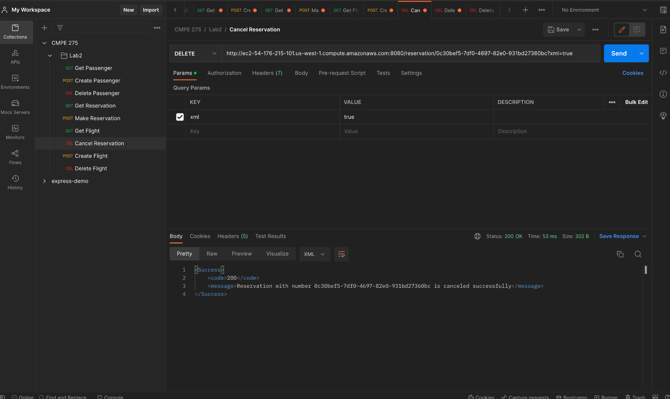

### **Get a flight**

* 1. **JSON URL:** <http://ec2-54-176-215-101.us-west-1.compute.amazonaws.com:8080/flight/01/2022-12-22?xml=false>

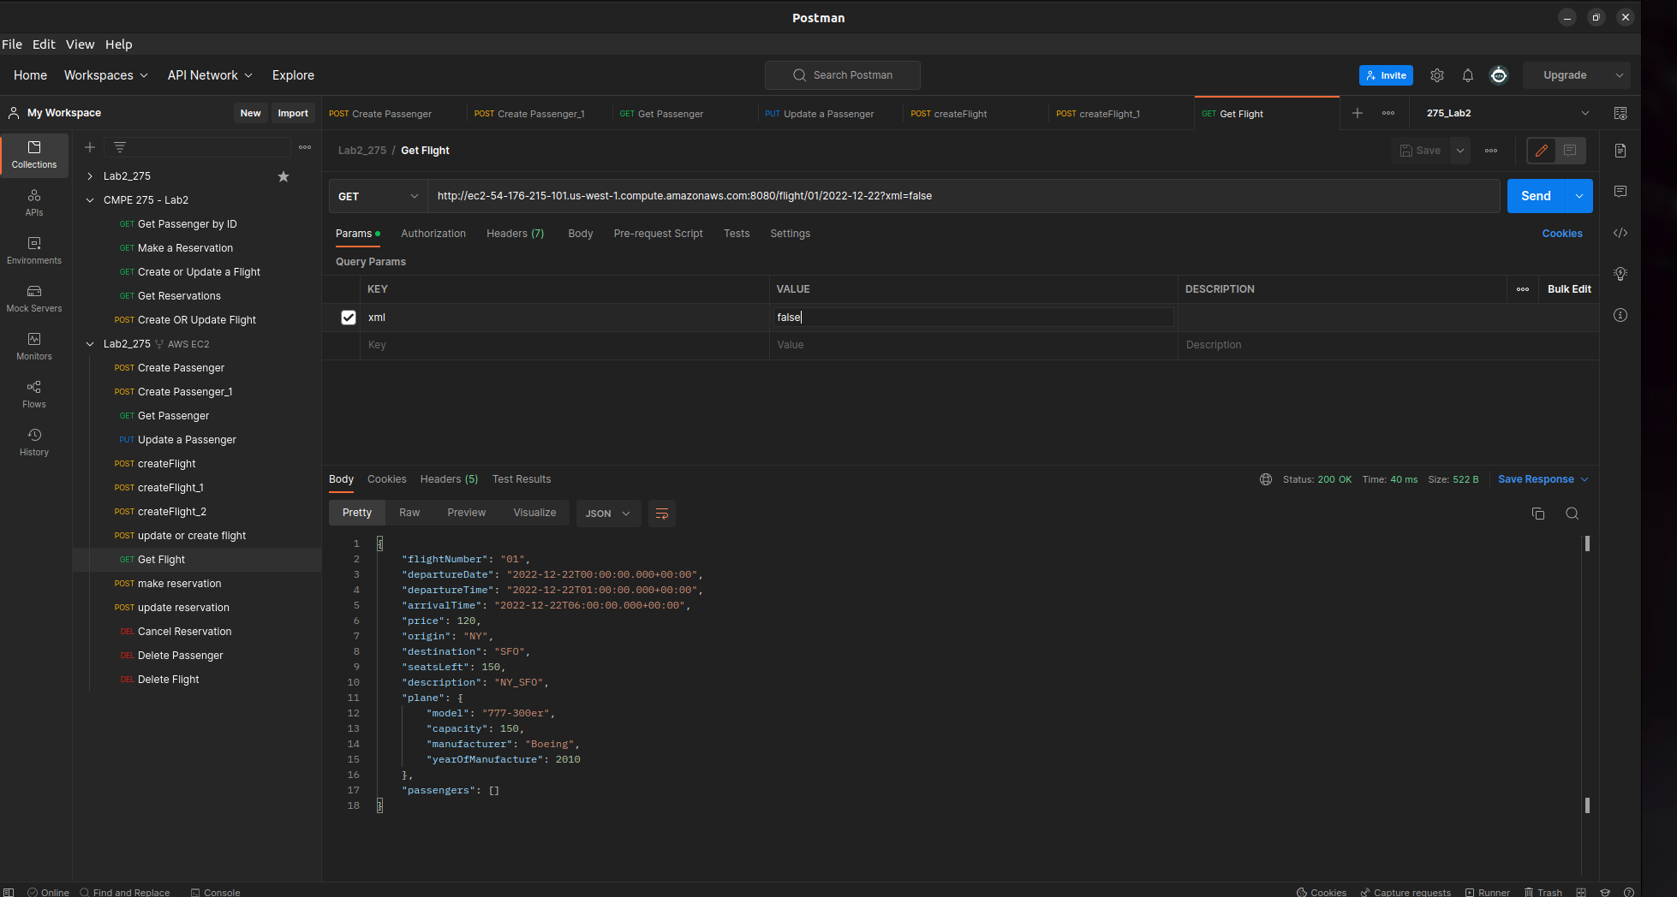

* 1. **XML URL:**

<http://ec2-54-176-215-101.us-west-1.compute.amazonaws.com:8080/flight/01/2022-12-22?xml=true>

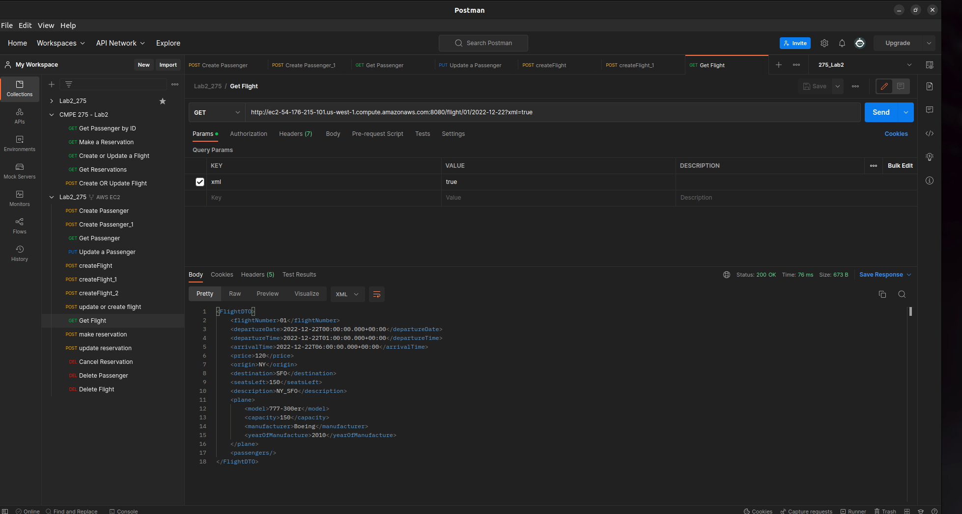

### **Create or update a Flight**

* 1. **JSON URL:** <http://ec2-54-176-215-101.us-west-1.compute.amazonaws.com:8080/flight/01/2022-12-22?price=120&origin=NY&destination=SFO&departureTime=2022-12-22%2001:00:00&arrivalTime=2022-12-22%2006:00:00&description=NY_SFO&capacity=150&model=777-300er&manufacturer=Boeing&yearOfManufacture=2010&xml=false>

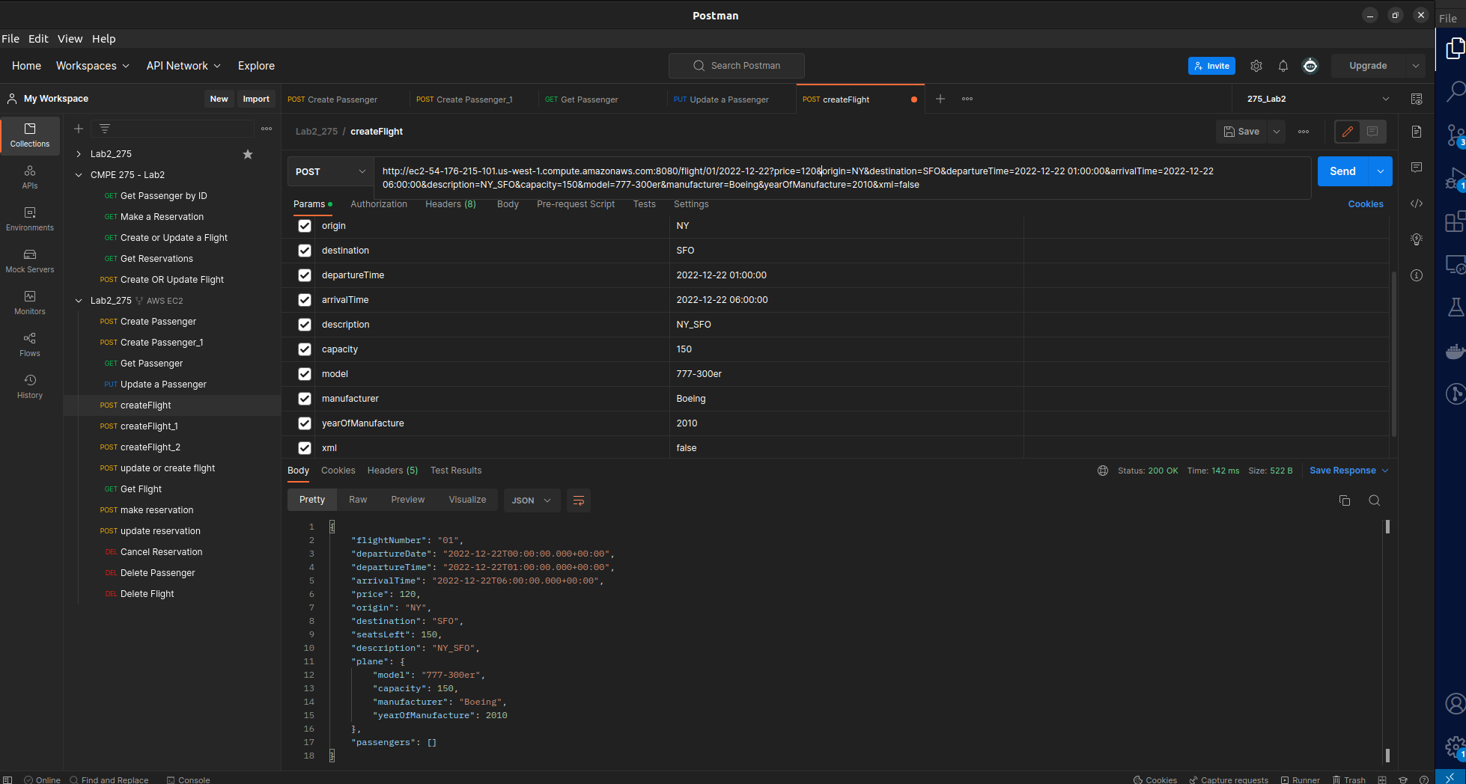

* 1. **XML URL:**

<http://ec2-54-176-215-101.us-west-1.compute.amazonaws.com:8080/flight/01/2022-12-22?price=120&origin=NY&destination=SFO&departureTime=2022-12-22%2001:00:00&arrivalTime=2022-12-22%2006:00:00&description=NY_SFO&capacity=150&model=777-300er&manufacturer=Boeing&yearOfManufacture=2010&xml=true>

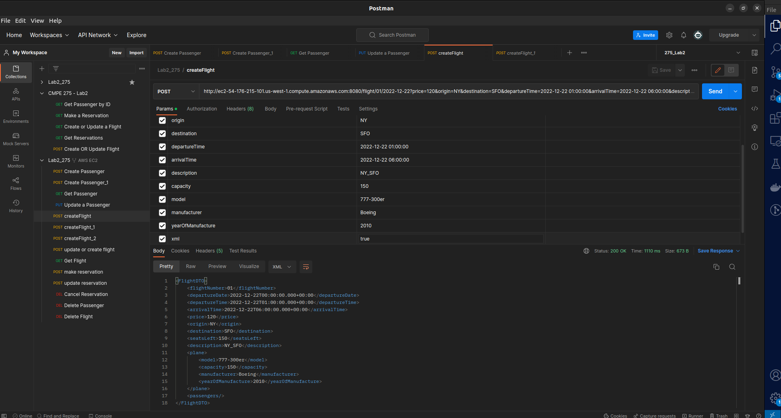

### **Delete a flight**

* 1. **JSON URL:** <http://ec2-54-176-215-101.us-west-1.compute.amazonaws.com:8080/flight/04/2022-12-22?xml=false>

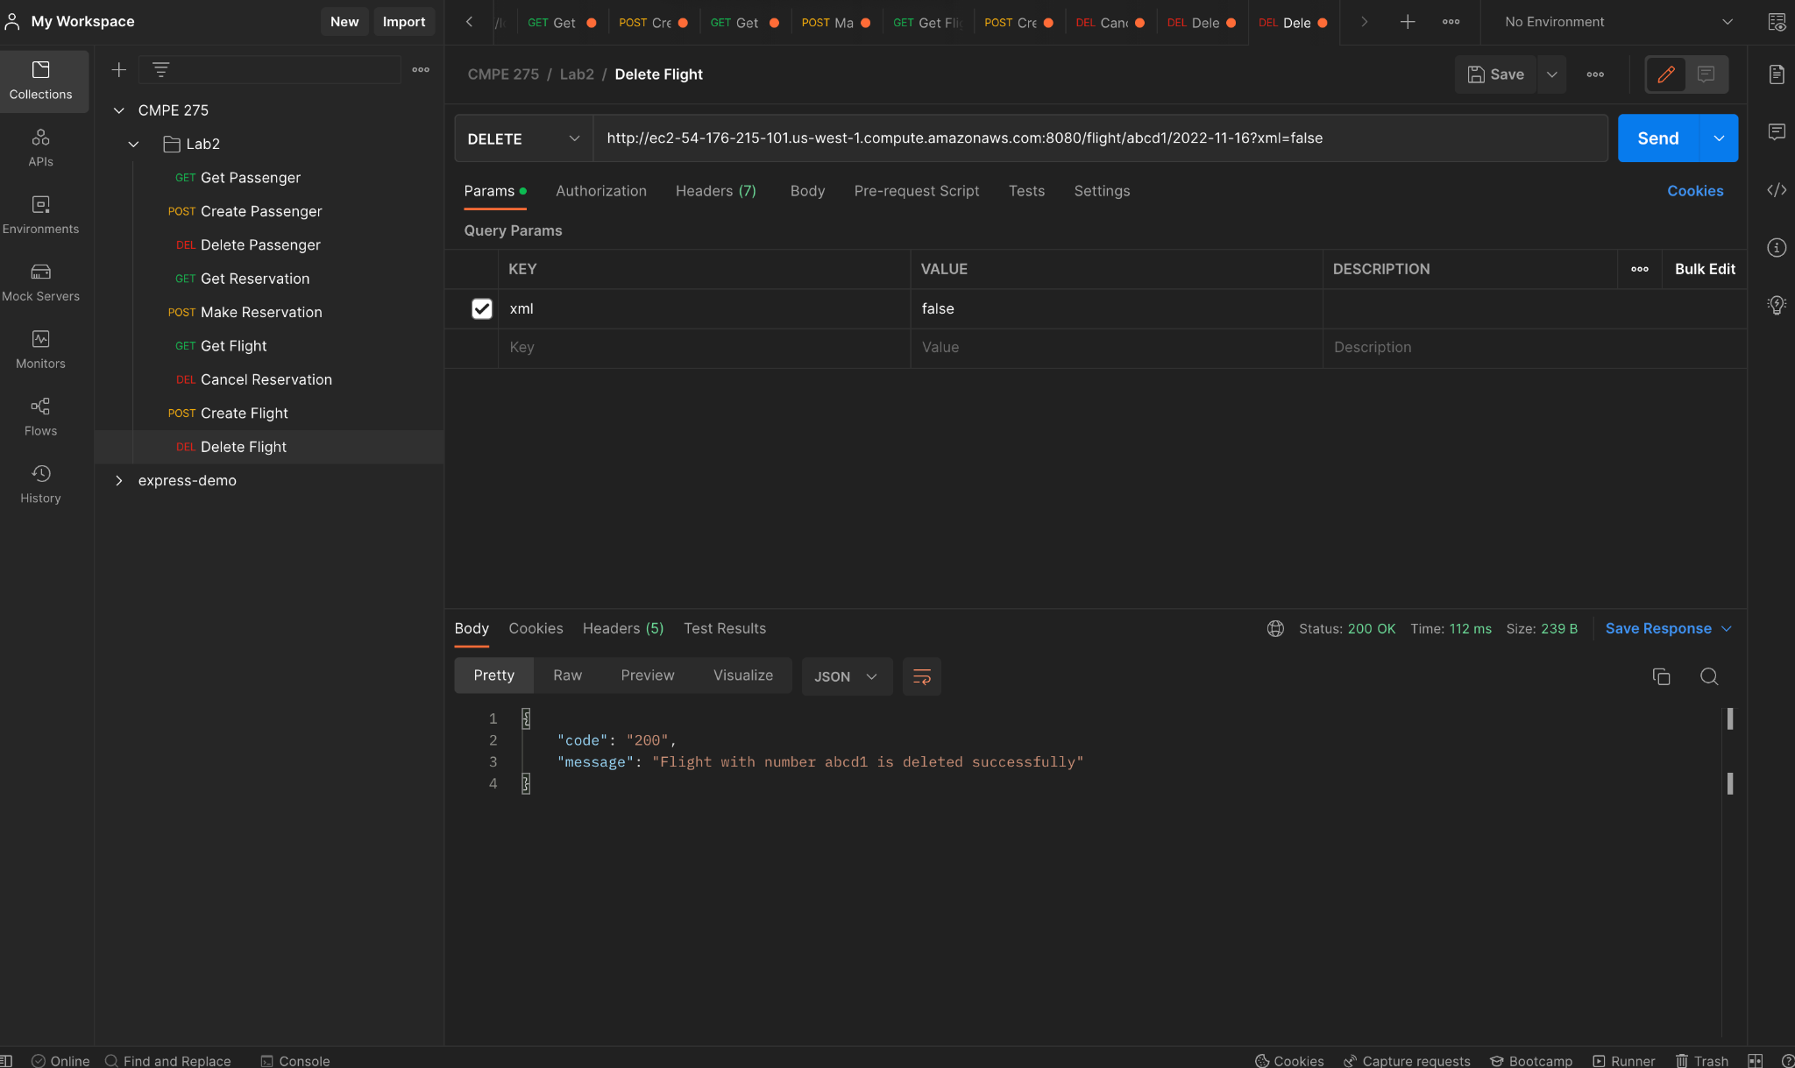

* 1. **XML URL:**

<http://ec2-54-176-215-101.us-west-1.compute.amazonaws.com:8080/flight/04/2022-12-22?xml=true>

